

**An-Najah National University**

**Faculty of Engineering and IT**

**Computer Engineering Department**

**web programming**

**10636316**

web project 2023

**Dr. sufyan samara**

|  |  |  |  |
| --- | --- | --- | --- |
| ***Student Name in English*** | ***Student Name in Arabic*** | ***Student ID*** | ***Work percentage*** |
| *Adham yaqoub* | *ادهم محمد احمد يعقوب* | *12028277* | *50%* |
| *Muheeb hasan* | *مهيب محمد عبد العزيز حسن* | *12010108* | *50%* |
|  |  |  |  |

Date/time: 15/12/2022

---------------------------------------------This section is intended for the instructor---------------------------------------

|  |  |
| --- | --- |
| **Topic** | **Mark** |
| Project Requirements and Modeling |  |
| Correctness of Database mapping |  |
| Functional Dependency and Normalization |  |
| Project Tools |  |
| Project Discussion |  |
| Project Completeness |  |
| Project Output Results or reporting (Jasper Report, charts, graphs, etc.) |  |
| Project Administration and Management |  |
| Project Report |  |
| Project Idea |  |
| Project Complexity |  |
| Team work |  |
|  |  |
|  |  |
|  |  |

Contents

Abstract: 4

Introduction: 5

Data Requirements 6

Project UML: 7

Tools used for Project: 8

GUI Discussion: 9

Data base table 26

▪Conclusion: 31

-REFRENCES: 32

# Abstract:

We have created a web project that represents a car store, and we have developed the project so that it achieves the greatest leadership for the customer and the business owner. The project consists of several windows, and we designed these windows in a way that makes it easier for the customer to deal with them as much as possible, and we made sure that the design is consistent with the idea of ​​the project and that all windows are compatible with changing the size The window and our keenness on color consistency so that the customer can easily enjoy using our site and help attract more customers. As for the manager pages, they were beautifully designed to make the work enjoyable for the owner and the highest level of efficiency and to achieve the greatest benefit and ease of dealing with him. Admin can edit products page by deleting and adding cars, and can also see orders and private messages from customers.

# Introduction:

We visited several private companies for the sale of cars in order to inform us about the nature of working in them and the most problems facing the customer and the owner of the company in the sales process and other things in order to try to develop them and reduce these problems as much as possible, and this site helps customers to find the request they want easily and attract many From customers, where he provides an accurate description of all the cars available in our store. When entering all the personal information required of the customer for the first time, an account will be created for him.

# Data Requirements

**Project Name: Car store**

**Project Description: creating website for special Car store store.**

-For each customer and manager, the database keeps information about

[**username**], [**password**]

- for each car [**name**], [**price**], [**image-name**].

Each customer can have a lot of car, and many customers can have the same car and thus a one-to-many relationship [**M: N**]

- And the manager can manage everything, all car are modified

(delete and add car), car are managed by one person “Manager”.

(So, the relation is **M: 1**)

# Project UML:

# Tools used for Project:

* Draw.io: used for create UML and referential integrity constraints.
* PhPStorm
* Xampp
* ImageVisual studio code



* Photoshope
* ImageImageFont libraries
* Bootstrap online library
* jQuery online library



* Colour picker
* Githup

# GUI Discussion:

**Home page:**

*Interface home page use nav bar for move from Section to another*

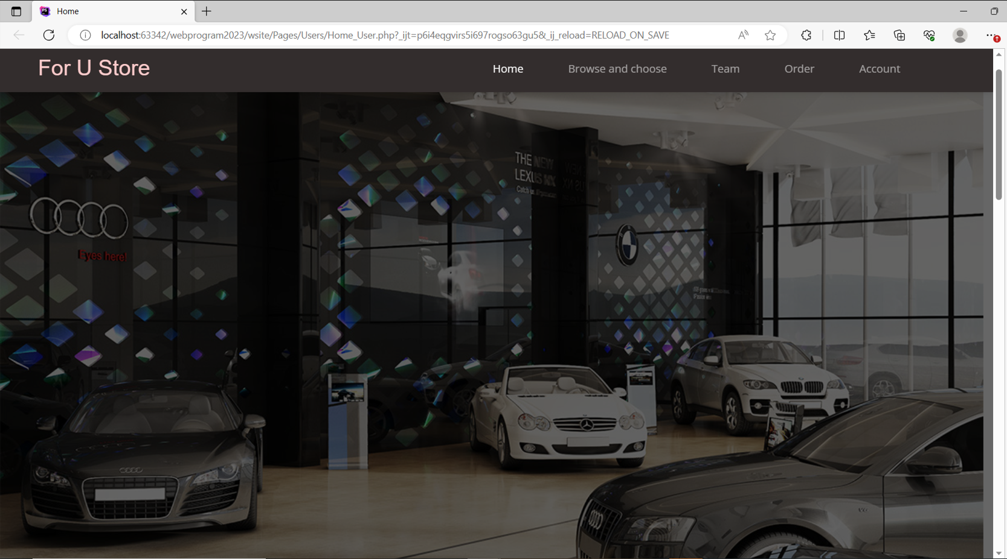

**Type of car section:**

Section for :select Type car to show the Product if hover the type car show name and button for move to another page

to select Type product for car

If click on any type move to product for the selected type.

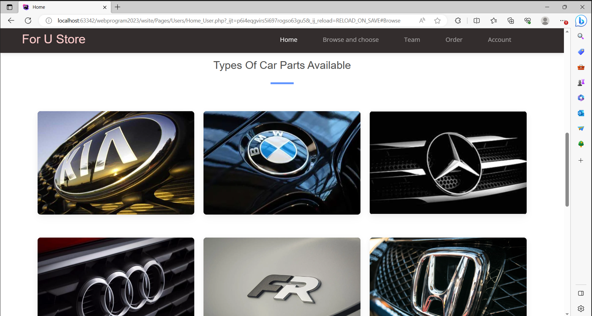

**Our team section:**

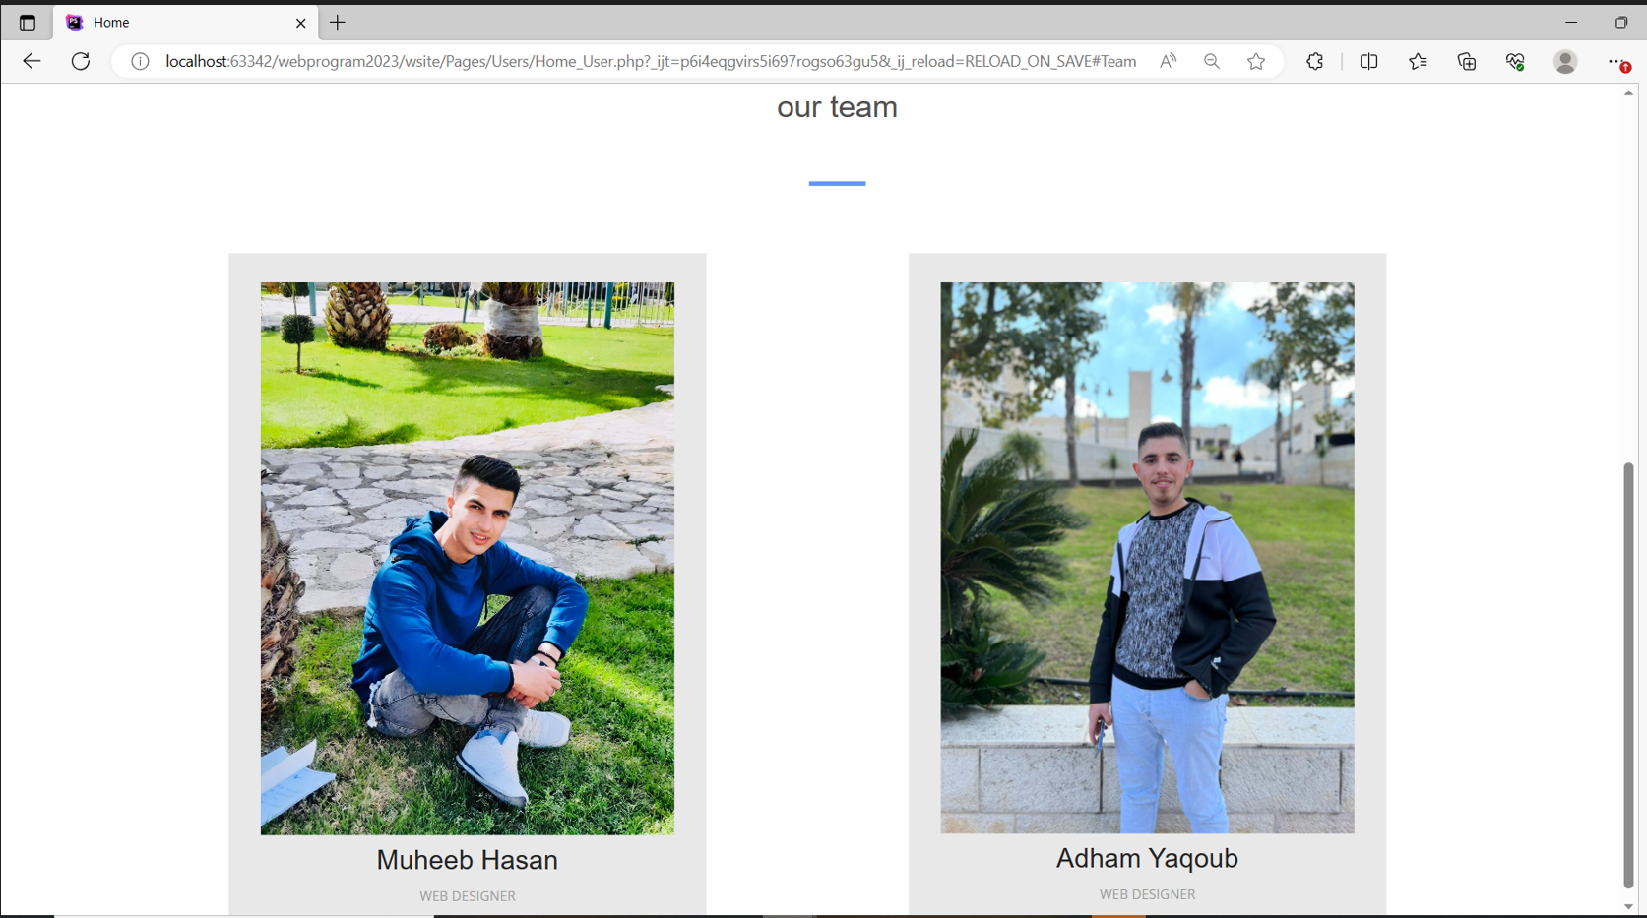

**Login Page :**

Through the login page, you can enter the site after verifying your identity through the username and password, so if the administrator or user each of them enters his own page

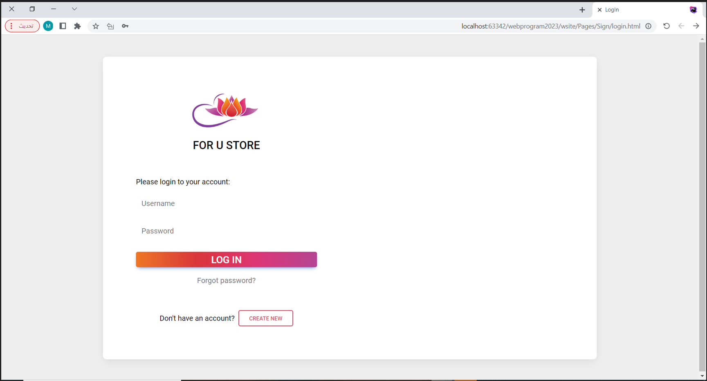

**SignUp:**   
Through the user registration page, you can create an account to enable you to purchase products. If you do not have a user, you can browse without purchasing.

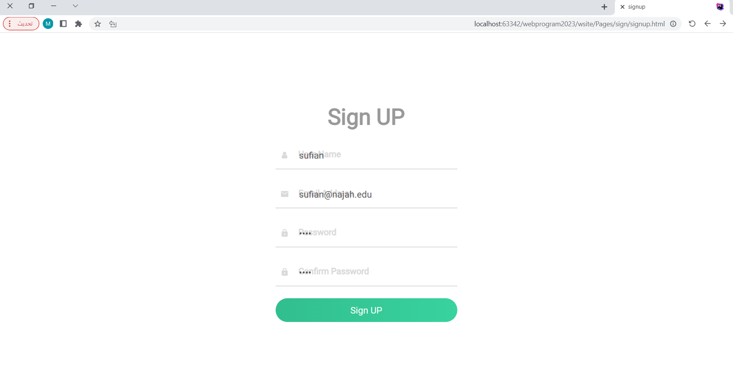

**Type product page:  
if we click of a Marcedes car then the next page is a more type of a Marcedes car company.**

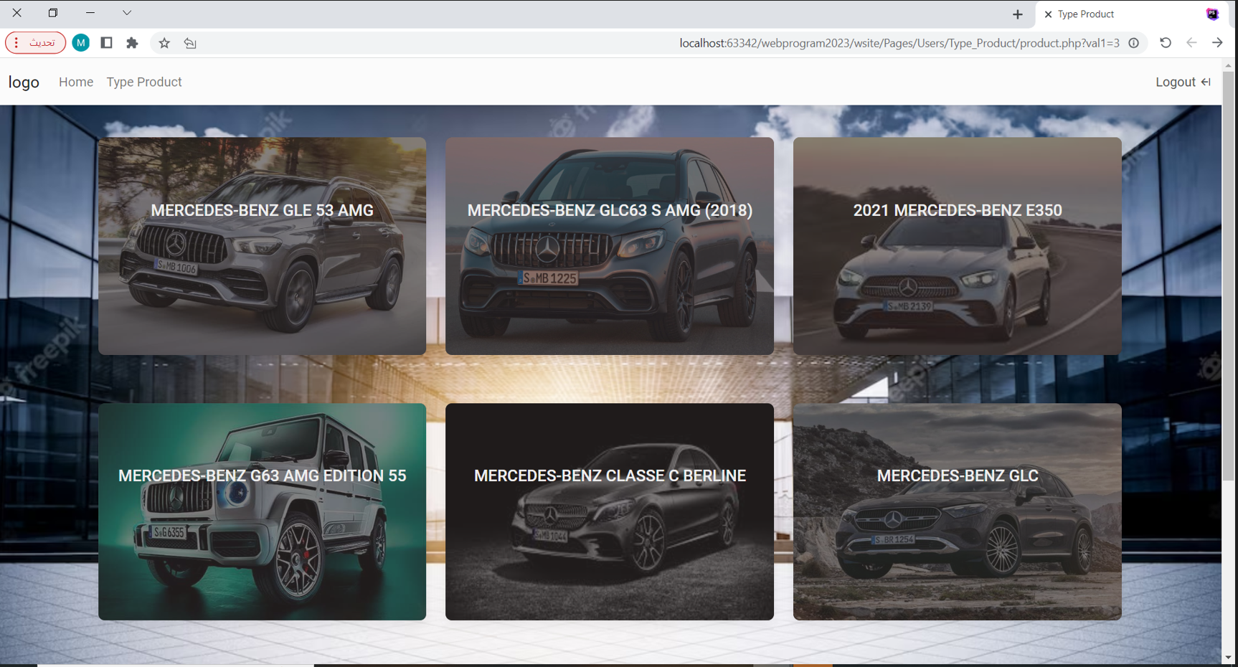

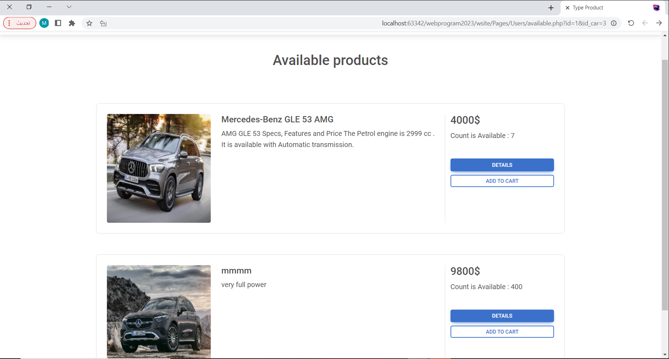

If click at icon cart move to your Cart Page .

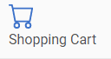

**The first section of the cart page** displays all the products currently in your cart. The product count is dynamically updated when you add or remove items. As the quantity of products changes, the total price is automatically adjusted accordingly. If you wish to remove a product from your cart, simply click the delete button located in the top right corner. This user-friendly design allows for easy management of your cart and provides real-time updates to ensure an efficient and seamless shopping experience.

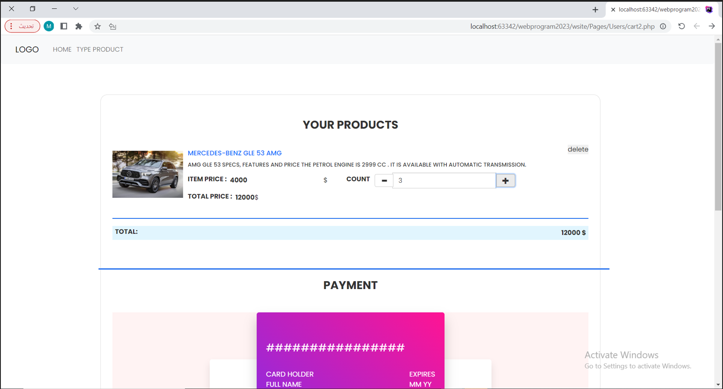

In the second section of the cart page, you can proceed to the payment and address details. To ensure secure transactions, we validate your Visa card using an API. Once you fill in the required information and click on the submit button, the API will verify the validity of your Visa card. If the validation is successful (true), your order will be placed successfully. This ensures that your payment information is protected, and you can confidently complete your purchase without any worries.

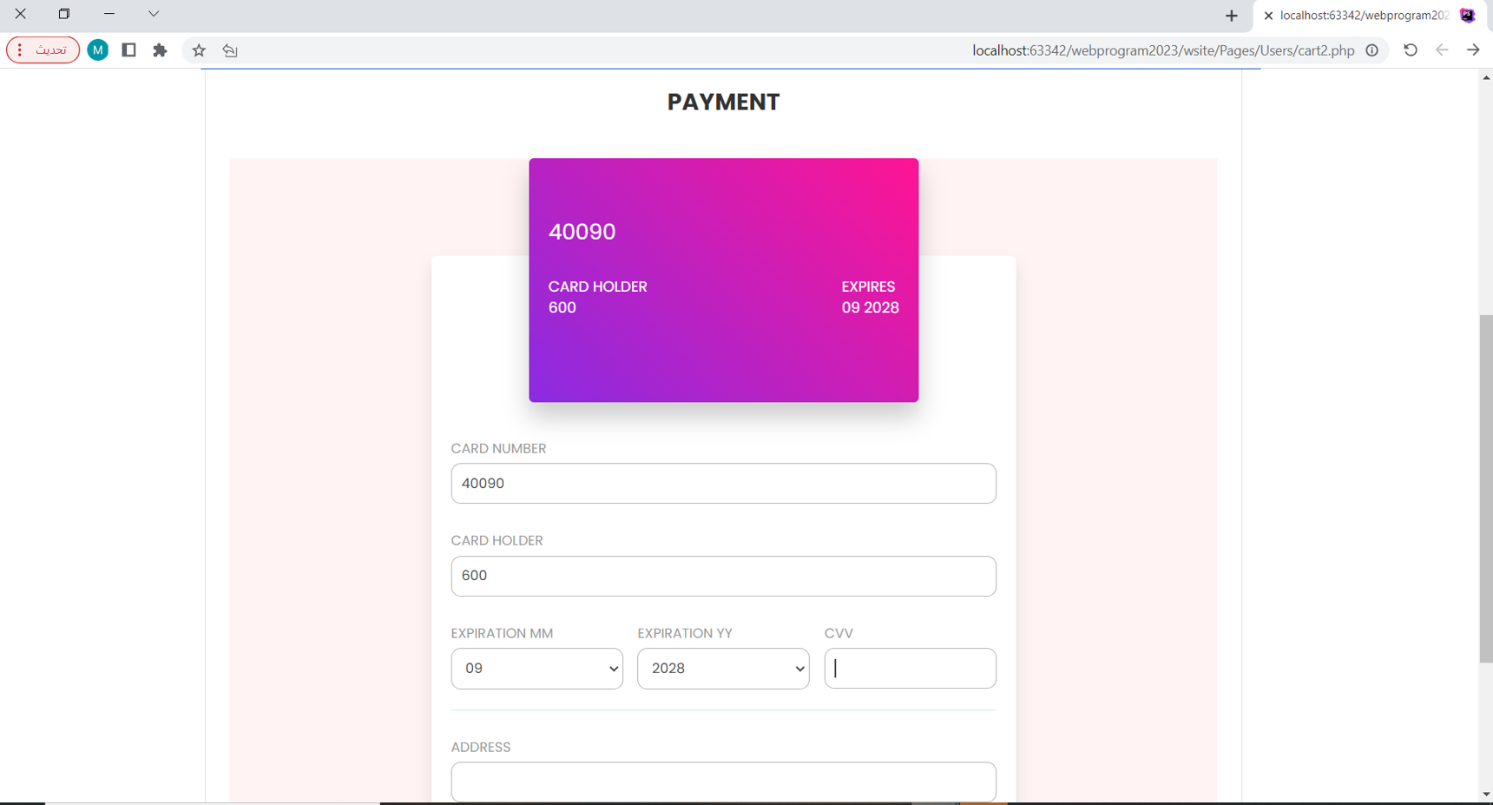

if write in input field change value in cart image

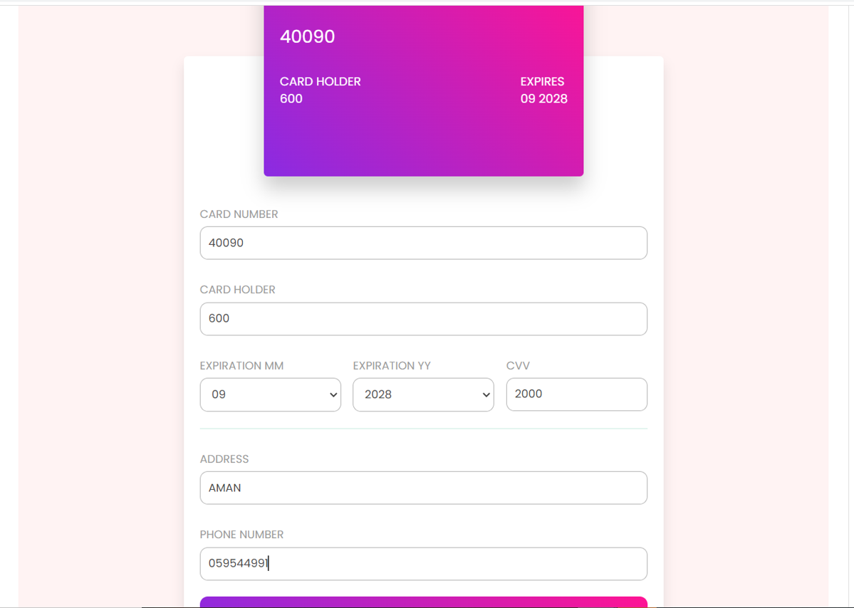

#End User Page#

The admin interface's dashboard page provides a comprehensive overview of key statistics related to the sales performance. It displays information such as the total number of completed and pending orders, the total number of registered users, and the overall count of orders placed. This consolidated view empowers administrators to have a quick grasp of the platform's performance and make informed decisions to optimize operations and enhance customer service.

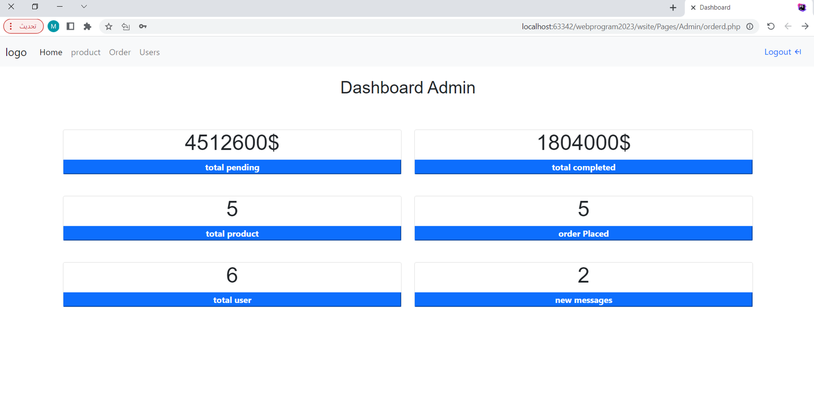

**Product Page :** first Section for add product

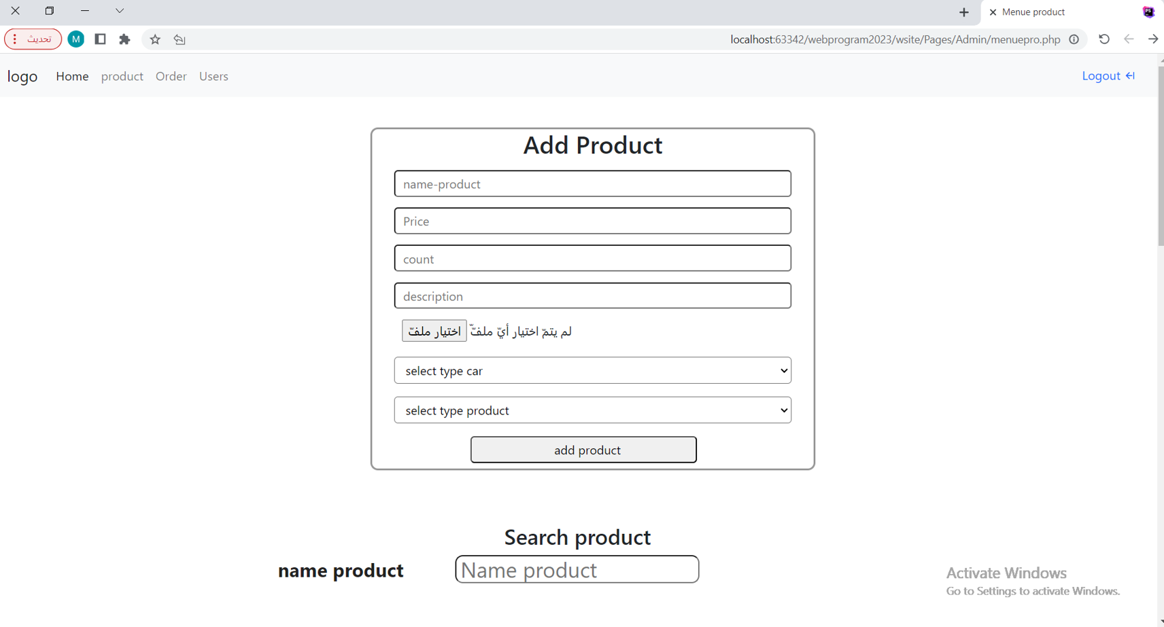

If click delete -> delete the product if not have any order from user but hidden product from all user.

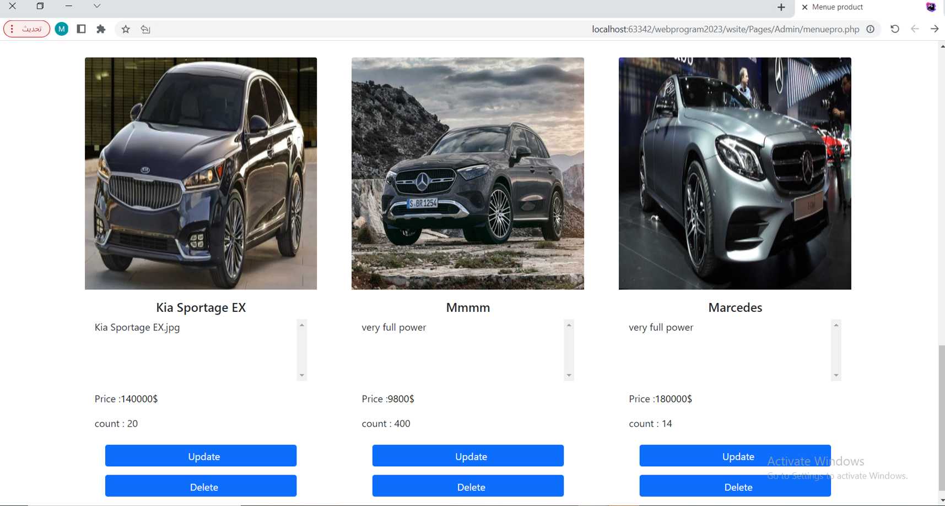

If click update show pop Up screen :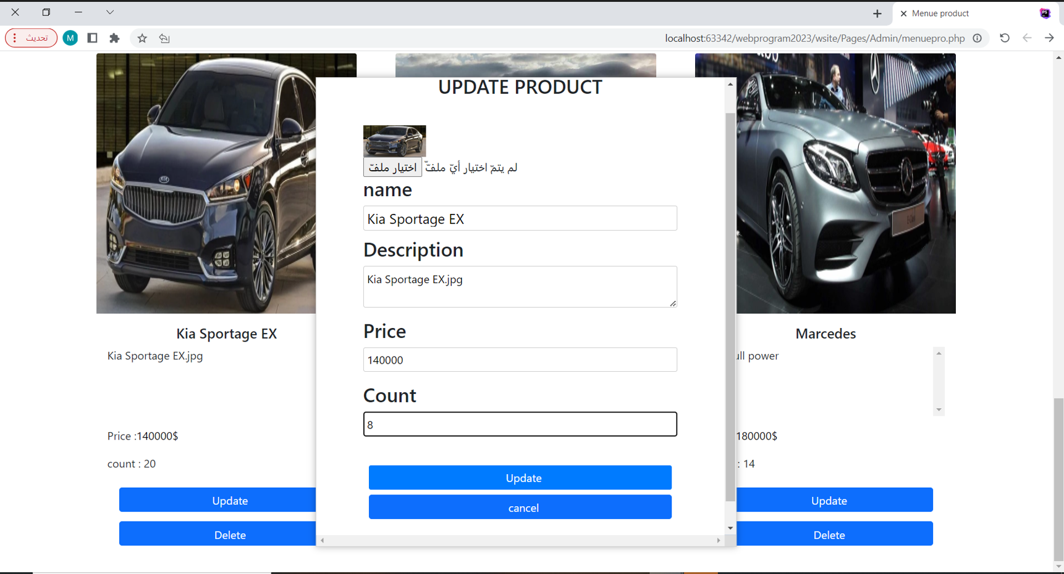

When clicking the "‘Update" button on the popup screen, the system automatically inserts the specified value and updates it for the corresponding product. This streamlined process ensures that changes are seamlessly applied, eliminating the need for manual intervention and improving overall efficiency.

On the Order page, when you click the "Update" button, you have the option to modify the status of the order. The default status is "Pending," but you can change it to "Complete" or "Shipped" depending on the current status of the order. This feature allows for easy management and tracking of orders, ensuring accurate and up-to-date information on each order's progress.

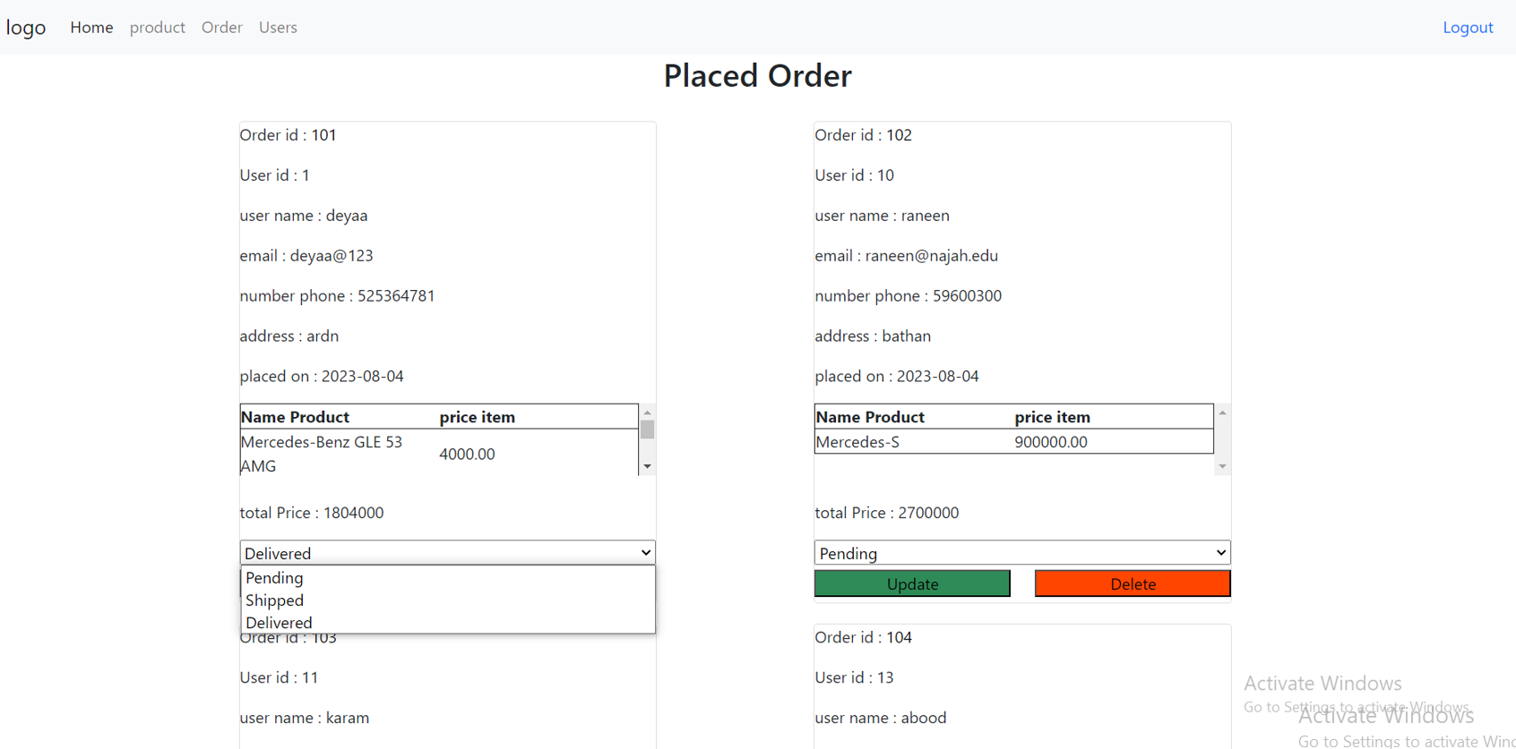

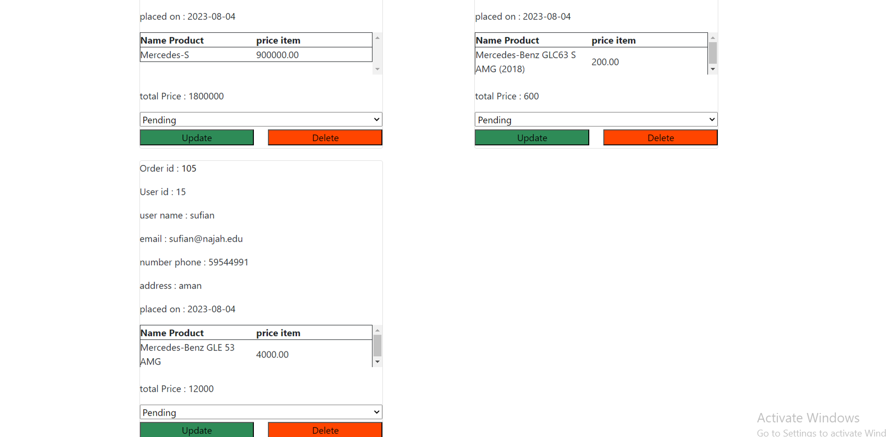

On the User page, you can make updates to user information without the need to submit a separate form. The changes you make are automatically saved in real-time. Additionally, if you wish to remove a user from the system, there is a delete option available for that purpose. This user-friendly interface allows for efficient user management with instant updates and the ability to remove unwanted accounts when necessary.

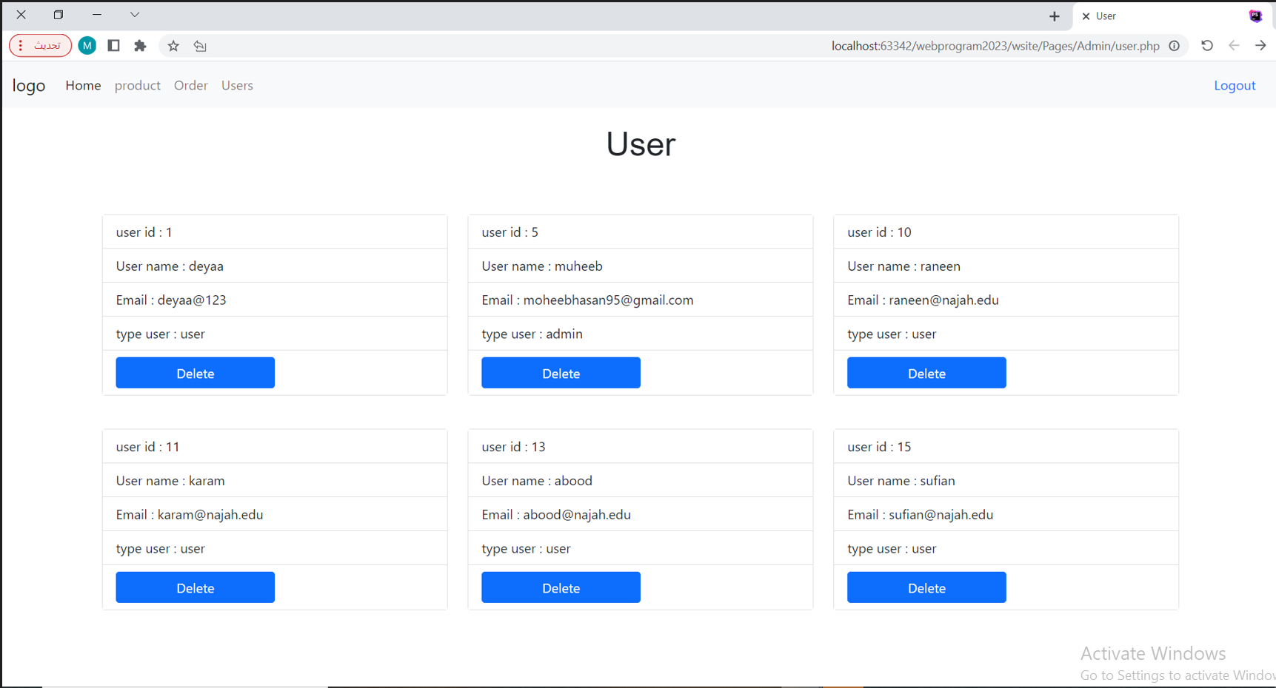

# Data base table

**This is the database table using xampp of a type of a car inside the store.**

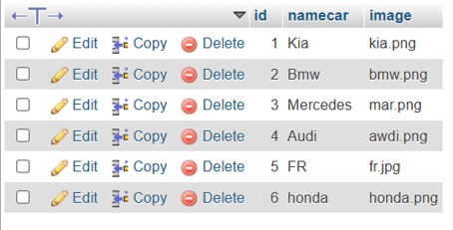

**This is the database table using xampp of a order.**

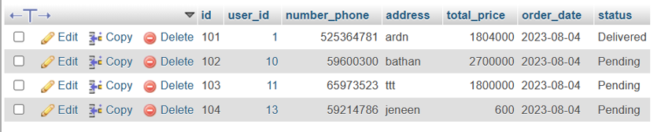

**This is the database table using xampp of a order-item.** 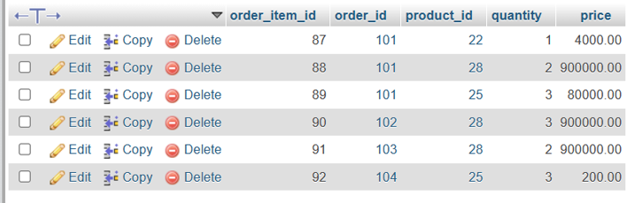

**This is the database table using xampp of a product.**

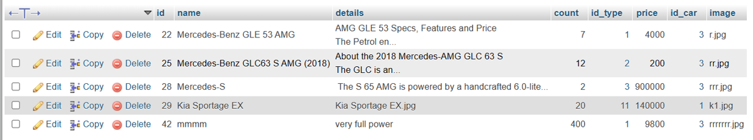

**This is the database table using xampp of a product.**

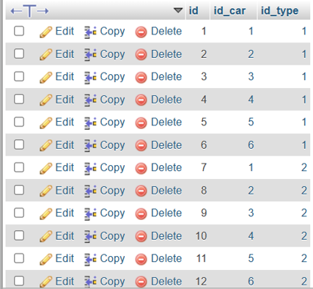

**This is the database table using xampp of a test.**

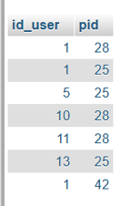

**This is the database table using xampp of a test-profuct.**

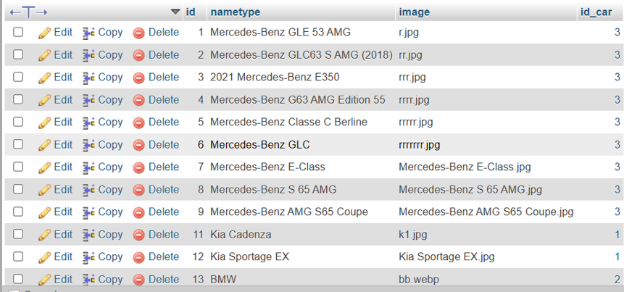

**This is the database table using xampp of a Type-profuct2.**

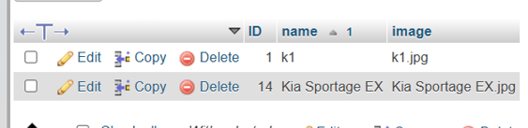

**This is the database table using xampp of a user.**

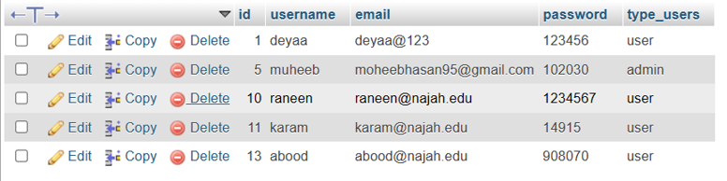

# ▪Conclusion:

In conclusion, this learning experience has been highly beneficial as I have gained valuable skills in working with Bootstrap, GitHub, and handling data of various sizes and types in databases. I have also learned how to efficiently transfer data between different interfaces and appropriately call them. Understanding the distinction between linking data in the database to web pages and effectively utilizing it has been insightful.

Throughout the process, I honed my proficiency in JavaScript, CSS, HTML, and PHP, which enabled me to create a dynamic program with an adaptable interface suitable for different devices. The responsive design ensured that users can interact with the elements seamlessly, regardless of their device size.

Furthermore, I have significantly improved my abilities in data analysis, database organization, and executing essential queries like Select, Update, Delete, Insert, and Join. This newfound expertise has empowered me to handle databases efficiently and make necessary modifications to optimize data management.

Overall, this learning journey has been comprehensive and rewarding, equipping me with the skills and knowledge to create well-designed and functional applications, work proficiently with databases, and enhance my overall development capabilities.

# -REFRENCES:

**1- php Documentation :**

<https://www.php.net/manual/en/>

**2-W3School:**

[W3Schools Online Web Tutorials](https://www.w3schools.com/)

**3-.MySQL:**

https://dev.mysql.com/doc/

**4-youtube:**

**Change Browser URL Without Refreshing Page:** [(2429) Change Browser URL Without Refreshing Page - Code With Mark - YouTube](https://www.youtube.com/watch?v=QvDmu0pe2fU&list=LL&index=1)

**5-Bootstrap:**

[Bootstrap · The most popular HTML, CSS, and JS library in the world. (getbootstrap.com)](https://getbootstrap.com/)

END